TASK 11: Continuous Testing in Jenkins for Dockerized Book Issue and Return System
Project: Dockerized Book Issue and Return System
Name: Swar Sawalkar
Roll No.: 23104B0023
Department: CMPN, Fourth Year
Division: C

1. Aim
To integrate Selenium WebDriver test cases into Jenkins, automate testing through a Jenkins pipeline, publish test reports and prevent deployment when test cases fail.
2. Introduction
Continuous Testing helps identify software defects whenever code changes are introduced. In this experiment, Jenkins is integrated with Selenium WebDriver and Maven to automate testing of the Dockerized Book Issue and Return System. The pipeline executes test cases and allows deployment only when all tests pass.
3. Objectives
- Integrate Selenium tests with Jenkins.
- Create a Jenkins pipeline using Jenkinsfile.
- Execute automated tests using Maven.
- Publish test execution reports.
- Stop deployment if any test fails.
- Introduce and correct a deliberate defect.
- Rerun the pipeline after correction.
4. Tools Required
- Jenkins
- Docker
- Selenium WebDriver
- Java
- Maven
- TestNG
- GitHub
- VS Code
5. Implementation
Step 1: Start Docker Application
docker-compose up -d --build
Step 2: Configure Jenkins
- Open http://localhost:8080.
- Create a new Pipeline project.
- Connect the GitHub repository.
- Configure Java, Maven and required plugins.
Step 3: Create Jenkinsfile
Create a Jenkinsfile in the project root directory.
pipeline {
agent any

stages {
stage('Checkout') {
steps {
git branch: 'main',
url: 'YOUR_GITHUB_REPOSITORY_URL'
}
}

stage('Build') {
steps {
sh 'mvn clean compile'
}
}

stage('Testing') {
steps {
sh 'mvn test'
}
}

stage('Publish Reports') {
steps {
junit 'target/surefire-reports/TEST-*.xml'
}
}

stage('Deploy') {
steps {
echo 'Tests passed. Deploying application.'
sh 'docker-compose up -d --build'
}
}
}
}
6. Defect Introduction and Correction
A deliberate defect was introduced in the book issue functionality.
Incorrect code:
book.setStatus("Available");
Corrected code:
book.setStatus("Issued");
A Selenium assertion verifies the expected status:
Assert.assertEquals(actualStatus, "Issued");
When the test fails, Jenkins stops the pipeline and skips deployment.
7. Defect Correction Commit
After correcting the defect, execute:
git add .
git commit -m "Fix book issue status defect"
git push origin main
Rerun the Jenkins pipeline using Build Now and verify that the tests pass.
8. Expected Results
Stage | Before Correction | After Correction
Checkout | Pass | Pass
Build | Pass | Pass
Testing | Fail | Pass
Reports | Published | Published
Deployment | Stopped | Executed
9. Screenshots to Include
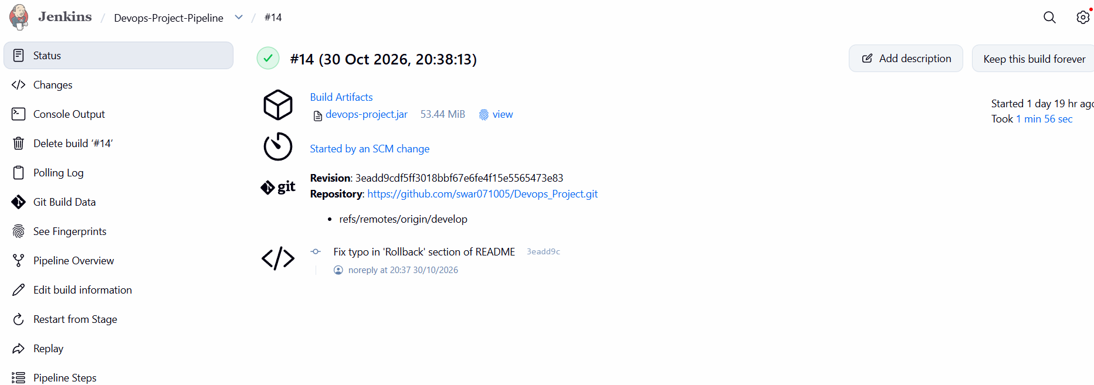
10. Advantages
- Automates software testing.
- Detects defects early.
11. Conclusion
In this experiment, Jenkins was integrated with Selenium WebDriver and Maven to implement continuous testing for the Dockerized Book Issue and Return System. A Jenkins pipeline was created to automate checkout, build, testing and report publication. A deliberate defect was introduced and corrected to demonstrate failure detection and deployment control. The corrected code was then committed and the pipeline rerun to verify successful execution.

